

4L30 Center Support Bushing

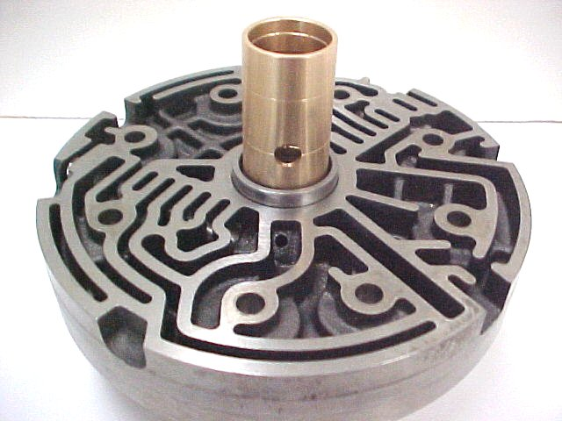
Part #
46410

Align large hole with curved
passageway as shown

The steel-backed bushing for the 4L30 is sloppy and allows line pressure to drop throughout the unit. Our bushing is machined closer (.002) and allows better control of pressure. If the band in your unit is cooked, check this bushing first.
The stock bushing needs a lot of pressure to extract it. Make sure your press has good supports under this CS or you can crack it.
Omega Machine & Tool, Inc.
“Precision and Innovation for Today”
11-9-06
Tel. 800 601 7722 – Fax 916 928 6020

